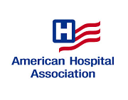

The AHA’s Institute for Diversity in Health Management and its Constituency
Section for Psychiatric & Substance Abuse Services

Join us for a Webinar and Discussion ___________________________________________________________________________
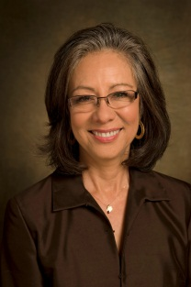
Disparities in Mental Health Care Among Diverse Populations

December 17, 2014
2:00 pm Eastern (1:00 pm Central, 12:00 pm Mountain, 11:00 am Pacific)
Expected Call Duration: 60 minutes

On behalf of the American Hospital Association and the Institute for Diversity in Health Management, we invite you to join us for a presentation and discussion on health disparities in mental health services among diverse populations.

Melba J.T. Vasquez, Ph.D., a past president of the American Psychological Association and psychologist in independent practice will describe how mental and behavioral health is especially a critical and frequently unaddressed issue for racial and ethnic minority communities. Disparities in availability of mental health services impacts patient care in general. The importance of recognizing cultural values and the patient’s relationship to the community will be discussed. She will also:

- Identify three possible reasons for disparities in utilization of mental health services by racial/ethnic minority populations.
- List key knowledge, skills and attitudes that may help providers promote increase in utilization of mental health services by racial/ethnic minorities.
- Review the American Psychological Association recommendations to eliminate disparities in mental health.

To register for the free webinar, click Here
A confirmation email will be sent to you upon completion of your registration. Please organize a central listening location in your organization if multiple parties wish to participate in the call. Log-in information and presentation materials will be sent the day before the webinar.
If you have any questions, please contact Cynthia Washington at 312-422-3996 or cwashington@aha.org .

We look forward to you joining us.

Fred Hobby Rebecca Chickey Cynthia Washington
President Director Director
Institute for Diversity Section for Psychiatric & Member Relations
in Health Management Substance Abuse Services

Participation in this call is by express written invitation of the AHA only. Unauthorized participants, and/or any party that aids and abets such unauthorized participants, may be subject to criminal and civil penalties under both state and federal law, including the Electronic Communication Privacy Act.

